|  |  |  |
| --- | --- | --- |
| **School of Computing and Information Technology** | Project 2  ISCG6420 IWD  Semester 2, 2022 | **1** |
| Create an Interactive Application.  Total Marks 100  Course Weighting 50%  **Save Point 1: 1 Nov 2022**  **Save Point 2: 7 Nov 2022**  **Due: 11:59pm 14 Nov, 2022** | |
|  |  | |

# Learning outcomes:

|  |
| --- |
| 1. Explain and apply the fundamentals of CSS (Cascading Style Sheets). |
| 2. Explain and apply the fundamentals of JavaScript. |
| 3. Use current client-side website development languages/technologies create a complex commercial or educational website. |
| 4. Use the features of Web/Multimedia authoring packages to create a complex commercial or educational website with effective navigational interface. |

**Project instructions:**

* You will work in pairs to create a website in your GitHub.
* Project consist of two parts

Part 1 – Create an online booking system for Wakatipu Boat Adventure

Part 2 – Create interactive game for children

* You will present your part 1 and 2 of the project to the class. Presentation is compulsory. Each pair will have 15 minutes to present their work.
* Your project homepage should include links to both parts. The example of project homepage layout is given below:

Example:

|  |
| --- |
| Wakatipu Boat Adventure |
| Documentation Part2  Documentation Part1  Play Game  Book Boat |
| Content |

**Project submission instructions:**

1. Your Project 2 web site is due by 11:59 **on 14 Nov, 2022.**
   1. Please put all your files in one folder. In the folder also include a signed cover sheet, this sheet includes declaration that “this submission is my own work, except where clearly referenced”.
   2. re-name the folder with this format - example project2_FirstStudentName_ID_ SecondStudentName_ID.
   3. ZIP this folder - using **zip program**. (DON'T use 7_zip. Don’t use rar!)
   4. Upload on Moodle link “Submission for Project 2”.
2. **Please upload your solution on Moodle submission link 14 Nov 2022**
3. A copy of your submission will be kept by School of Computing and Information Technology for future reference and audit purposes for two years.

**Part 1 – Create online seat reservation system for Wakatipu Boat Adventure**  **[45 Marks]**

You will develop an online booking system for Wakatipu Boat Adventure, using XML as external storage and using JSON to communicate with external APA. Weather is permitting, two boats are available for booking. User can pre-order simple meals/ snack during booking as well.

1. Provide documentation for your application. Make the document link available on landing page.
2. Consider the following criteria given below while developing an online booking system:
   1. Load your boat data settings from XML files. Users should be able to specify a different number of people and select a date, time and boat name. Date range only from today and up to next 4 days. Booking time should be 10 am and 2 pm. Your booking page’s layout outline is up to you. Boat seats layout is given and should be used as presented on the next page (page 3). Please note it is not fully developed booking page, it is only a boat example, it is not demonstrating all requirements.
   2. Boat layout must be link to data from XML file (Boat name, rows, ‘number of seats’). This data is presented dynamically on booking page. Booking page is providing a popup information on “mouse over” for each seat.
      1. Some seats have already been taken, so users cannot book them.
      2. Each seat price for first two rows is $30, for next three rows it is $25, and for the rest it is $20.
      3. Different boats can accommodate a different number of people. Each row and seat should have a unique number.
      4. During booking (if it is not for today), weather permission should be checked using external API. Booking allows if no rain and temperature is above 14 C. Weather condition should be taking from open API, please apply for your own API key. <https://openweathermap.org/api>. Weather condition for today should be displayed on booking page.
      5. Populate Boat menu dynamically on the webpage. Menu must be link to data from XML file (image names, description, cost, special requirements)
      6. When populating each menu item layout consider the following:
         1. User must be able to dynamically see a list of menu items. Each item has image, description, type indication (vegetarian, egg free, gluten free) and cost. You need to have as minimum 6 items on your menu.
         2. User can select item and specify amount (for example: 2 Chicken sandwiches). Total for current selection should be display, that user can do informative choice.
         3. If user wants to change their selection, the system should be able to update dynamically.
      7. On user confirmation (boat, seats numbers and menu selection) the booking system should calculate total price and provide a full statement/ list of selected items and seats number. Summary for booking should have: date, time, name of boat, seats number, number of people coming, menu selected and total cost.
      8. After booking confirmation is done, seats should be marked as unavailable/booked for that time and selected date.
      9. If user decided to add additional seat(s) for same day and booking time, his earlier selected seats should be marked as booked.

Tere Boat layout

|  |  |  |  |  |  |  |  |  |
| --- | --- | --- | --- | --- | --- | --- | --- | --- |
|  |  |  |  |  |  |  |  |  |
|  |  |  |  |  |  |  |  |  |
|  |  |  |  |  |  |  |  |  |
|  |  |  |  |  |  |  |  |  |
|  |  |  |  |  |  |  |  |  |
|  |  |  |  |  |  |  |  |  |
|  |  |  |  |  |  |  |  |  |
|  |  |  |  |  |  |  |  |  |
|  |  |  |  |  |  |  |  |  |

Nui Boat layout

|  |  |  |  |  |  |  |  |  |
| --- | --- | --- | --- | --- | --- | --- | --- | --- |
|  |  |  |  |  |  |  |  |  |
|  |  |  |  |  |  |  |  |  |
|  |  |  |  |  |  |  |  |  |
|  |  |  |  |  |  |  |  |  |
|  |  |  |  |  |  |  |  |  |
|  |  |  |  |  |  |  |  |  |
|  |  |  |  |  |  |  |  |  |
|  |  |  |  |  |  |  |  |  |
|  |  |  |  |  |  |  |  |  |
|  |  |  |  |  |  |  |  |  |
|  |  |  |  |  |  |  |  |  |
|  |  |  |  |  |  |  |  |  |
|  |  |  |  |  |  |  |  |  |

**Part 2 –Interactive online game [35 Marks]**

You will design and develop an interactive web game for young children using HTML5 elements including Canvas.

**Game story:**

The main character is walking in the nature and try to catch and collect flying bugs. The main character’s design and look is up to you. It can be a person, or an animal (It will be called Mr X for now). Mr X’s task is to catch all bugs and avoid them as they try to attack Mr X’s. Every catch bug will get a score of one. If a bug land on Mr X, then a score will be deducted by one.

**The story board for the game is as follows:**

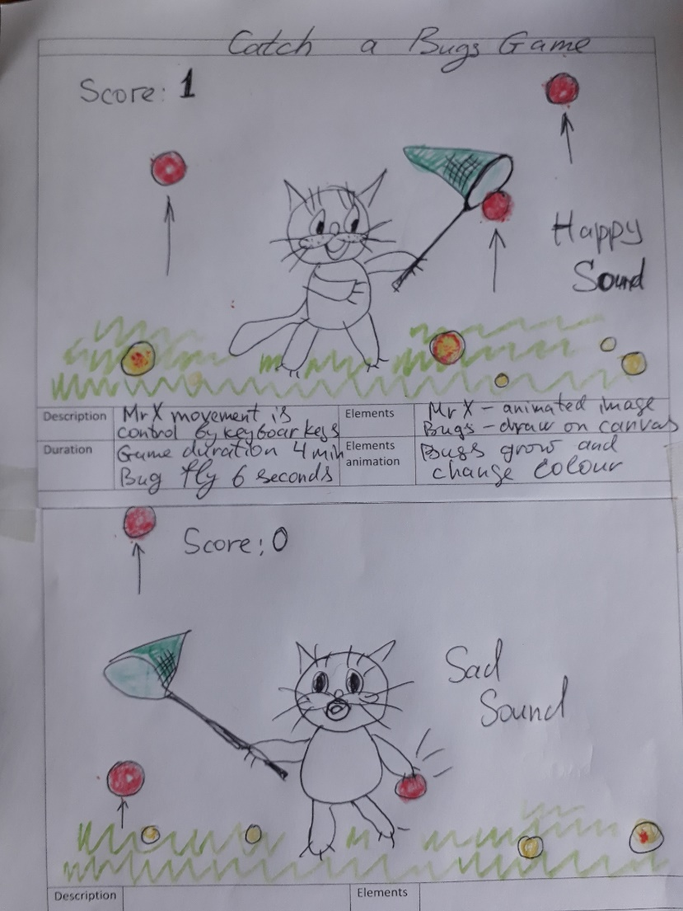

**Game development requirements:**

Character Mr X:

* Mr X movement is controlled by using the keyboard arrow keys (up, down, left, right).
* You should have additional key (for example “space”) to allow to move catch net.
* Catch net direction changes, when Mr X moves left or right. Each time Mr X changes direction the catch net should be in front of Mr X.
* Mr X movement is restricted inside the canvas.
* Every time Mr X successfully catch bug, a score of one is added to the current score and a ‘happy’ sound is played. However, if the bug touch Mr X, an ‘unhappy’ sound will be played and some image displayed and current score will be deducted by one.
* Define and implement Mr X animation (eyes movement, legs movement, tail movement, ears movement)

Each bug has a life cycle which is described below:

Stage 1: a small yellow bugwith a radius = 6px will appear randomly on the bottom side of canvas.

Stage 2: growing time for each bug is 5 seconds. Each bug grows to size of radius = 20px

Stage 3: bug’s colour changes gradually from yellow to red in a duration of 3 seconds. Use radial gradient in diagonal direction for the colour change.

Stage 4: Each red bug will stay on the bottom for a duration of 4 seconds and will then start move up or fly up.

Stage 5: movement time for each bug is 6 seconds to cross a playable area.

Stage 6: bug moves fly out of vision if Mr X is unable to catch it. Or if it moves on the any side of Mr X it should bite Mr X and after disappear.

Additional requirements for the game:

1. Minimum 4 different sounds in the game (like two different collision beep and start and end game sounds) and users should be able to control the volume of the sounds.
2. Provide feedback with appropriate text messages and sound to the player. For example, a mechanism to display the score to the player or text message in the end of game.
3. Time settings which can be changed by player. Default time setting for duration of game is 4 minutes. Other possible value for the duration of the game is 1, 3 and 5 minutes.
4. Start button and restart button.
5. Overall design and complexity of scenery – background.
6. Provide documentation for your application. Make the document link available on landing page.

# Part 3 – Individual Task 20%

The grading for this component is weighted depending on how you performed in your homework tasks submitted on time, 10% contribution to the course grade will be taken for each homework’s across all IWD course; 10 homework - 10 marks; each mark is 2%.

Each homework task must be done by course commence day and any delay up to 3 days will be result in 50%-mark deduction, all other delay is 0% marks.

## Possible sources of information

You can use resources such as academic journals, web sites and other Internet sources, class discussions and handouts, journals, newspapers and magazines, books. You need to provide the reference of all the when referencing web sites, you should, where possible, give the author, title and date of the resources, and the full URL of the page(s) referred to, rather than just the address of the home page.

## Delivery

You web site is due by 11:49Pm **14 Nov , 2022.**

**Save point 1-**

1. Part 1 -Wireframe for your Project 2 landing page, Wireframe(s) for booking system with steps to outline how user will proceed with booking.
2. Part 1 Requirements -according to point 2 Marking criteria.
3. Part 2 Wireframe for game page and Game storyboard.
4. Homepage for your project 2 (index.html)
5. Part 2 Character movements according to point 2 Marking criteria.

**Save point 2-**

1. Part 1 – 3,4, 5 ,6 according to Marking criteria
2. Part 2 - 2, 3 according to Marking criteria

**Full submission:**

1. You web site is due by 11:49Pm **14 Nov, 2022.**
2. (storyboard(s) and wireframe(s) should be attached to your homepage as links)
3. A softcopy of your web site must be uploaded on models using Project one submission link before the deadline. Please use a **zip file**, it should have a name project2_YourName_YourID_OtherStudentName_ID
4. Your web site must upload to GitHub on 11:49Pm **14 Nov. You will create folder with your secret name and send me link by email.** This will prevent other student from copy your work.
5. One page as a standard cover sheet softcopy should be presented in your zip folder as well (please download cover page from Moodle). **This page must include a signed declaration that “this submission is my own work, except where clearly referenced”.**
6. **For the purposes of academic integrity, students who haven’t demonstrated progress work in the class time (and/or no check point submission) can be asked to demo/test their working code and explain logic to the lecturer individually after assignment submission.**

A copy of your submission will be kept by Computer Science Practice Pathway for future reference and audit purposes.

## Marking Guide

Marks for your work will be given according to the following marking schedule:

|  |  |  |  |
| --- | --- | --- | --- |
| **No** | **Item** | **Criteria** | **Marks** |
|  | **Part 1** |  |  |
|  | Provide documentation for your application.  **(5 marks)**   * XML data design (two files) * User booking design page(s) wireframe(s) for booking system with steps to outline how user will proceed with booking. * Testing (Test Cases, as minimum 4 test cases) * Link on the landing page | 5 marks = both the design are in Pdf format and link(s) to the landing page is working. Clear explanation of presented data for XML data dictionary and wireframe provided for User booking design page, which has all details required for booking.  2-4 marks = one or two details in documents are missing or link(s) not working or quality of documentation is not up to standard.  1 mark = one of the document is submitted with number of errors, second document is not submitted. |  |
|  | Dynamic translation Wakatipu Boat Adventure name from Maori language to English.  User should be able to select a date, time and number of people coming. After that system allow to select particular boat, and seats number  **(3 marks)** | 3 marks = all three input elements correctly used to develop desired functionality.  2 marks = as above with minor problems. Or one input element missing completely.  1 mark = minimum one element working |  |
|  | Load Wakatipu Boat Adventure boat settings from XML files. **(5 marks)**   * XML files are defined and linked in the code. * java-script reading from XML files. * Class for seat is defined. * Array of instances for each seat are populated dynamically. | 5 marks = all the criteria are met.  2-4 marks = one or two minor details are missing  1 mark = number of details are missing  0 = hard coded values for table array |  |
|  | Populate each boat layout dynamically on the webpage. **(9 marks)**   * + User must be able to dynamically see seat number; is it available or not and cost for each seat.   + Already booked seats clearly indicated in your layout and user should not be able to select them for booking.   + User can change his/her mind and select other seats | Total 3 marks = for each area layout  For each boat layout  3 marks = all criteria are met.  2- marks = up to three minor functionally not working based on the requirements.  1-2 marks = more than three of functionally not working based on the requirements |  |
|  | User must be able to dynamically see a list of menu items. Each item has image, description, type indication (vegetarian, egg free, gluten free) and cost. Minimum 6 items on your menu.  **(6 marks)** | Total 6 marks = criteria are met.  3 -5marks = most of criteria are met.  2- marks = up to three minor functionally not working based on the requirements.  1 marks = more than three of functionally not working based on the requirements |  |
|  | If user wants to change their booking selection they system should be able to update dynamically. **(3 marks)** | 3 marks = booking price is correctly calculated by the system based on the user selection.  1-2 marks – some error(s) |  |
|  | On user confirmation (boat name, seats numbers and menu selection) the booking system should calculate total price and provide a full statement/ list of selected items and seat(s) number(s). Summary for booking should have: date, time, name of Wakatipu Boat Adventure boat, seat’s number(s), number of people coming, menu selected and total cost. Date range only from today and up to next 4 days **(5 marks)** | 5 marks = booking information is display correctly and price is correctly calculated by the system based on the user interaction. User can see a correct summary for his /her booking  2-4 marks = booking information is display correctly and price is correctly calculated by the system based on the user selection. User can see a summary but some or number of details are missing.  1 marks = only total is provided and other details are missing |  |
|  | After booking confirmation is done- seat(s) should be marked as unavailable/booked for that time and selected date.  **(3 marks)** | 4 marks = criteria are met.  2-3 mark if minor error in implementation. Like seats booked for all week. |  |
|  | using JSON to communicate with external APA, weather check done correctly for today booking Weather condition for today should be displayed on booking page **(6 marks)** | 6 marks = all criteria are met.  2-5 marks = up to one or two minor functionally not working based on the requirements.  1 marks = more than three of functionally not working based on the requirements |  |
|  |  |  |  |
|  | **Part 2** |  |  |
|  | Mr X movement is controlled by using the keyboard arrow keys (up, down, left, right).  **(11 marks)**   * It also needs additional key to turn the move catch net (for example- blank space). * Mr X direction changes, when Mr X moves left or right. Each time Mr X changes direction the move catch net should be in front of Mr X. * Mr X movement is restricted inside the canvas. * Every time Mr X successfully catches an bug, a score of one is added to the current score and a ‘happy’ sound is played. * Define and implement Mr X animation (eyes movement, legs movement, tail movement, ears movement) | 11 marks =All criteria are met.  9-10 marks =All criteria are met with minor error or errors in implementation. For example: Mr X can run out of one side of canvas.  5-8 marks =Most criteria are met with a few errors in implementation.  2-4 marks =Some criteria are met with a number of errors in implementation.  1 marks = A number of problems in program only a few things work with minor error. |  |
|  | However, if a bug touch on Mr X, an ‘unhappy’ sound will be played and current score will be deducted by one.  **(12 marks)**  Stage 1: a small yellow bug with a radius = 6px will appear randomly on the bottom of canvas.  Stage 2: growing time for each bug is 5 seconds. Each bug grows to size of radius = 20px  Stage 3: bug’s colour changes gradually from yellow to red in a duration of 3 seconds. Use radial gradient in diagonal direction for the colour change.  Stage 4: Each yellow bug will stay on the bottom for a duration of 4 seconds and will then start move.  Stage 5: movement time for each bug is 6 sec.  Stage 6: bug moves fly out of vision if Mr X is unable to catch it. Or if it moves on the any side of Mr X it should touch and disappear. | 12 marks = Bug’s life cycle met all criteria described.  9-11 marks = Bug’s life cycle met all criteria described with some minor error or errors in one or two bug’s stage.  5-8 marks =Most criteria are met with one of stages missing and some minor error in other bug’s stage implementation.  .  2-4 marks =Only some criteria are met with a number of errors in implementation.  1 marks = A number of problems in enemies stage’s. |  |
|  | Additional criteria for the game: **(8 mark)**   * Minimum 4 different sounds in the game and users should be able to control the volume of the sounds. * Provide feedback with appropriate text messages and sound to the player. For example, a mechanism to display the score to the player or text message in the end of game. * Time settings which can be changed by player. Default time setting for duration of game is 4 * minutes. Other possible value for the duration of the game is 1, 3 and 6 minutes * Start button and restart button. * Overall design and complexity of scenery – background. | 8= all additional game’s criteria are met.  6-7=if one or two additional criteria are missing and/or functionality work partly  2-5 = if more than 2 additional criteria are missing  1 = only one additional criteria implemented with some minor error. |  |
|  | Additional criteria for the game:  Provide documentation for your application.  **(4 mark)**   * Your own game storyboard Wireframe for game page. * Testing (Test Cases, as minimum 4 test cases) | 4 marks = both the design are in Pdf format and link(s) to the landing page is working.  2-4 marks = one or two details in documents are missing or link(s) not working or quality of documentation is not up to standard.  1 mark = one of the document is submitted with number of errors, second document is not submitted. |  |
|  | Presentation **(-10 mark – if no presentation)** |  |  |
|  | **Save Point 1: Complete**  **Part 1 – 1, 2, 3**  **Part 2 -1 plus storyboards** |  |  |
|  | **Save Point 2: Complete**  **Part 1 – 4, 5 ,6**  **Part 2 -2, 3** |  |  |
|  | **Total marks** |  |  |

**Rules for Late Submission of Assignments**

a. The due dates of assessment work will be notified in course information.

b. Assignments submitted after the due date and time without having received an extension through Special Assessment Circumstances (SAC) will be penalised according to the following:

•         10% of marks deducted if submitted within 24hrs of the deadline

•         20% of marks deducted if submitted after 24hrs and up to 48hrs of the deadline

•         30% of marks deducted if submitted after 48hrs and up to 72hrs of the deadline

•         No grade will be awarded for an assignment that is submitted later than 72hrs after the deadline.

c. Students submitting assignments after the due date and time will be ineligible to resubmit a failed assignment.

**Affected Performance Consideration:**

A student, who due to circumstances beyond his or her control, misses a test, final exam or an assignment deadline or considers his or her performance in a test, final exam or an assignment to have been adversely affected, should complete the Affected Performance Consideration (APC) form available from the Student Central.

When requesting APC for an assignment, the APC must be submitted (along with work completed to date) within the time frame of the extension requested; i.e. if the Doctor’s certificate is for one (1) day, then the APC all work completed all work up to this day must be submitted on an application day.

**Academic Misconduct**

Cheating and Plagiarism are considered Academic Dishonesty and will be dealt with under the provisions of the Student Disciplinary Statute.

Do you want to do the best that you can do on this assignment and improve your grades?

You could:

• Talk it over with your lecturer

• Visit Te Tari Awhina or Maia for learning advice and support

• Visit the Centre for Pacific Development and Support

• Contact the USU Advocate for independent advice

• For contact details and more information, go to www.usu.co.nz